THE AMERICAN TRIBUTE TO CHOPIN
Celebrate the 200th birthday of one of the world's
most beloved composers, Frederic Chopin!

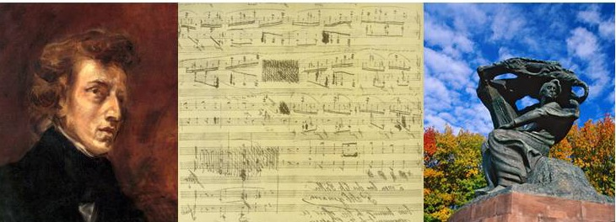

March 19, 2010, 6:00 p.m.
Kosciuszko Foundation - New York
(15 East 65th St., New York, NY 10065)

6:00 p.m. Panel Discussion- "Chopin and Music in the 21st Century"
7:00 p.m. Concert (followed by reception)

Program:
Piano Concerto in F-minor by F. Chopin
Sonata for Cello and Piano by F. Chopin
Nocturne in G minor by F. Chopin
Introduction and Polonaise Brillante by F. Chopin
New York premiere of “An American Tribute to Chopin," composed by Elizabeth Borowsky

Performers include:
Cecylia Barczyk, cello
Elizabeth Borowsky, piano
Emmanuel Borowsky, violin
Frances Borowsky, cello
Reynaldo Reyes, piano
Chopin Quartet
Tickets and reservations:
Tel.: 212-734-2130 or 410-426-6062
Email: chopin@intermusearts.org
Web: www.americantributetochopin.org

